4MP HD IR VF Dome Network Camera
IPC3534LB-ADZK-G
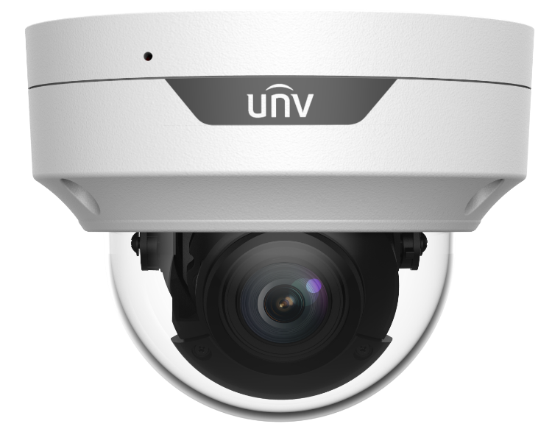

Key Features
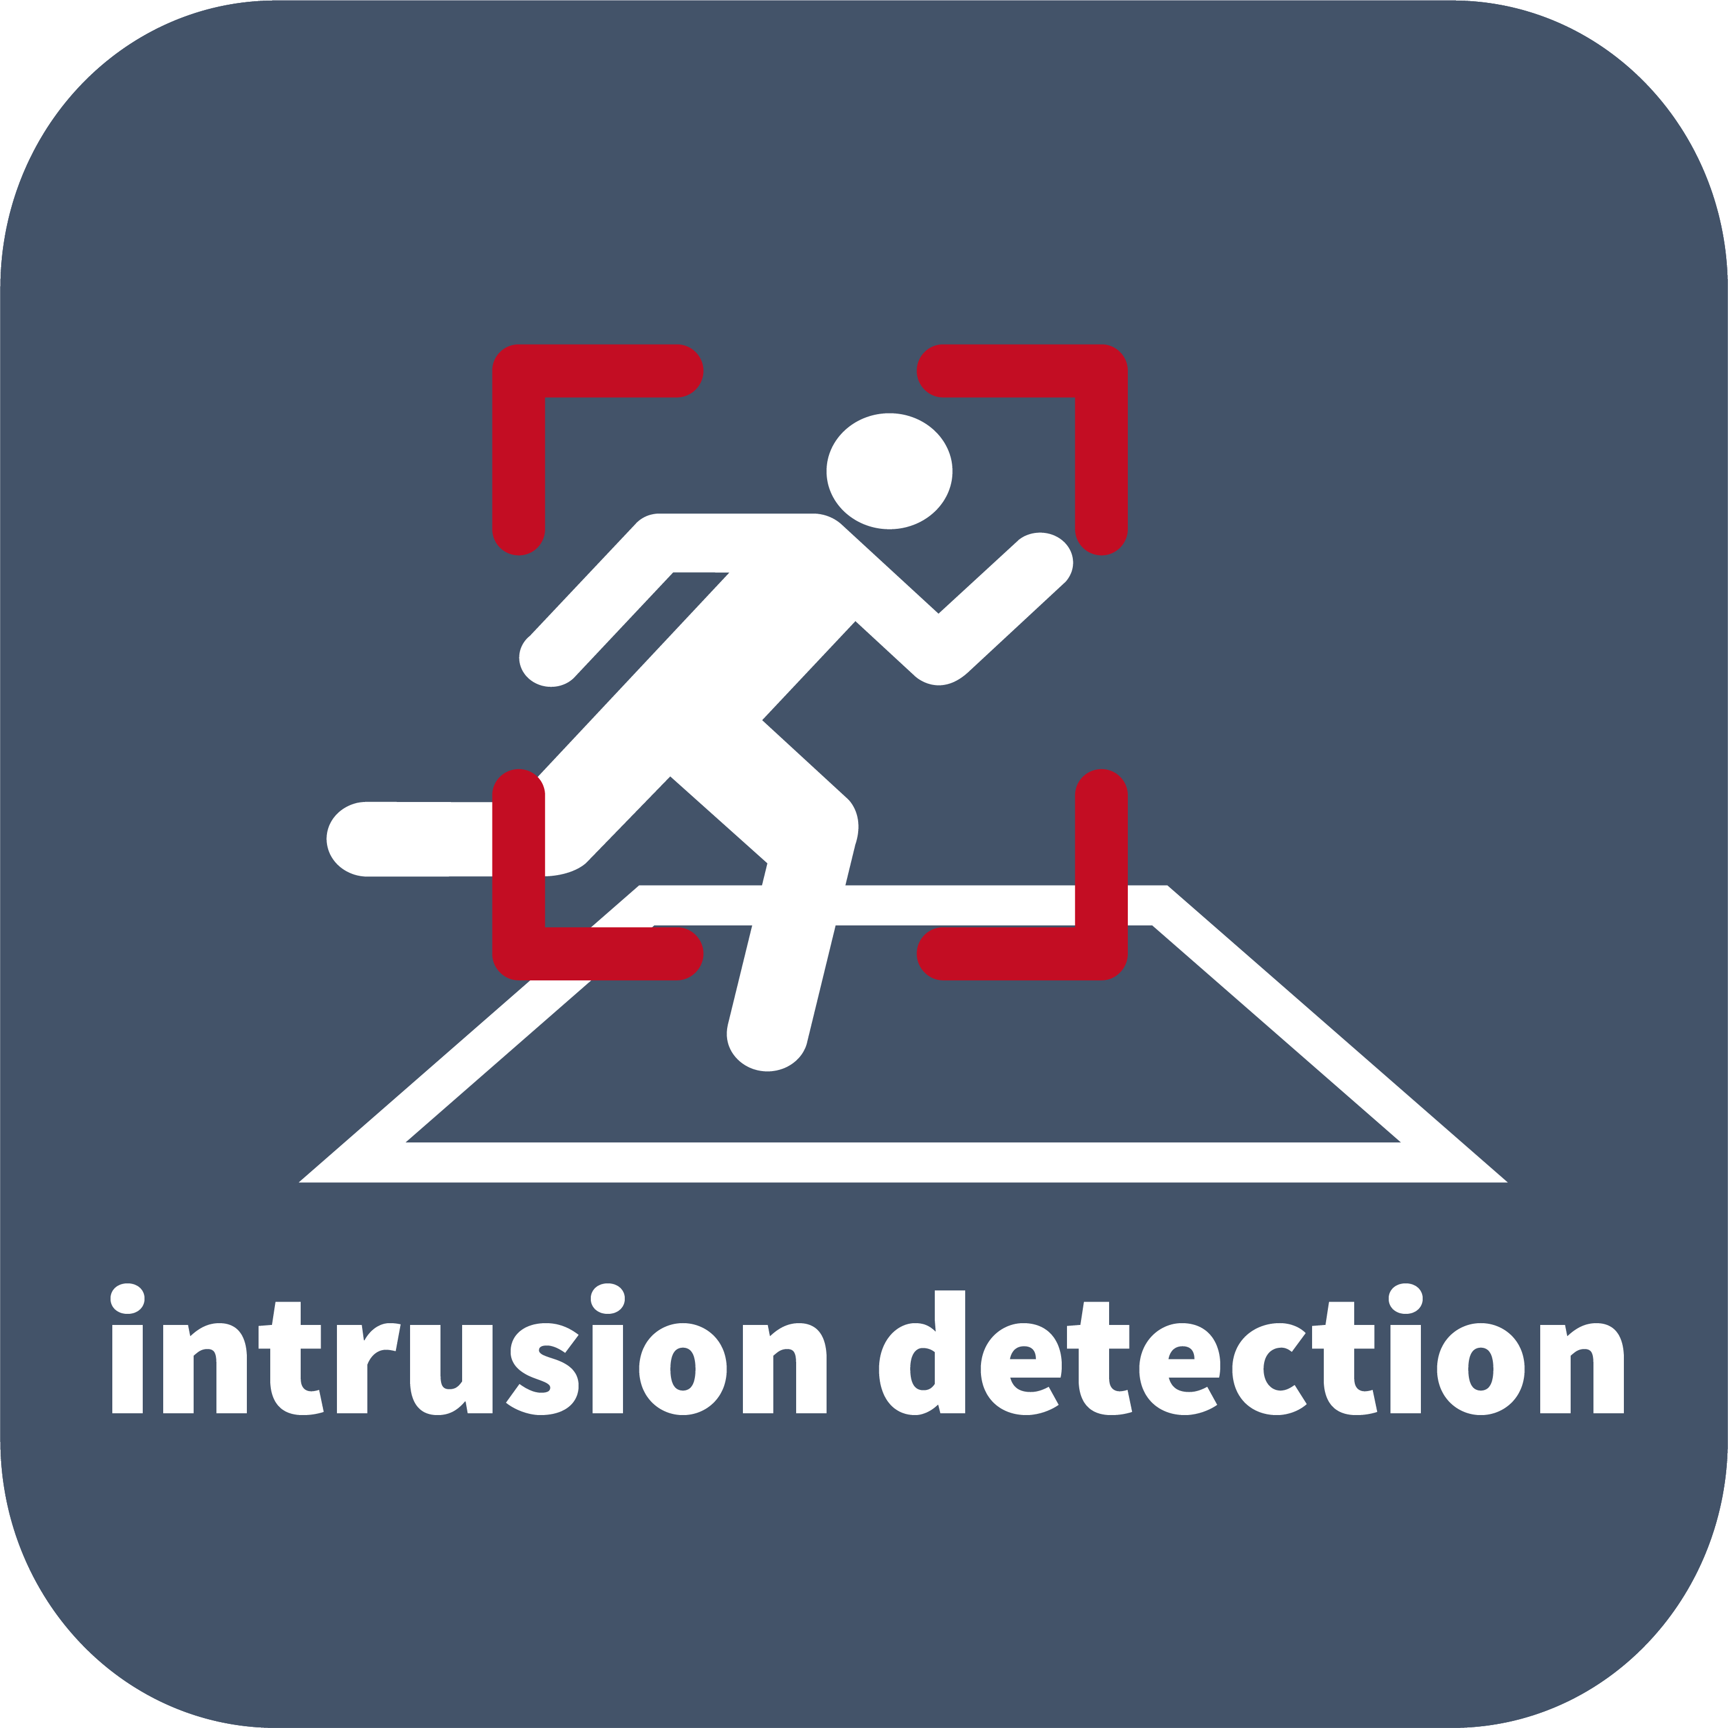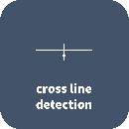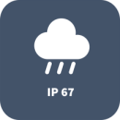

- High quality image with 4MP, 1/3"CMOS sensor
- 4MP (2688*1520)@ 25/20fps; 4MP (2560*1440)@ 25/20fps; 3MP (2304*1296)@ 30/25fps;2MP (1920*1080)@30/25fps
- Ultra 265, H.265, H.264, MJPEG
- 120dB true WDR technology enables clear image in strong light scene
- Support 9:16 Corridor Mode
- Built-in Mic
- Smart IR, up to 40m (131ft) IR distance
- Supports 256 G Micro SD card
- IK10 vandal resistant
- IP67 protection
- Support PoE power supply
- 3-Axis

Specifications
 | IPC3534LB-ADZK-G
Camera
Sensor | 1/3", 4.0 megapixel, progressive scan, CMOS
Lens | 2.8 ~ 12mm, AF automatic focusing and motorized zoom lens
DORI Distance | Lens (mm) |  | Detect (m) |  | Observe (m) | Recognize (m) |  | Identify (m)
DORI Distance | 2.8 |  | 42 |  | 16.8 | 8.4 |  | 4.2
DORI Distance | 12 |  | 180 |  | 72 | 36 |  | 18
Angle of View (H) | 102.79°~ 30.86°
Angle of View (V) | 54.50°~ 17.49°
Angle of View (O) | 106.94°~35.49°
Adjustment angle | Pan: 3° ~ 360° |  |  | Tilt: 0° ~ 70° |  |  | Rotate: 3° ~ 360°
Shutter | Auto/Manual, 1 ~ 1/100000s
Minimum Illumination | Colour: 0.003Lux (F1.6, AGC ON)  0Lux with IR
Day/Night | IR-cut filter with auto switch (ICR)
Digital Noise Reduction | 2D/3D DNR
S/N | >56dB
IR Range | Up to 40m (131ft) IR range
Wavelength | 850nm
IR On/Off Control | Auto/Manual
Defog | Digital Defog
WDR | 120dB
Video
Video Compression | Ultra 265, H.265, H.264, MJPEG
H.264 code profile | Baseline profile, Main profile, High profile
Frame Rate | Main Stream: 4MP (2688*1520), Max 25fps; 4MP (2560*1440), Max 25fps; 3MP (2304*1296), Max 30fps; 1080P (1920*1080), Max 30fps;  Sub Stream: 720P (1280*720), Max 30fps; D1 (720*576), Max 30fps; 640*360,Max 30fps; 2CIF(704*288), Max 30fps; CIF(352*288), Max 30fps;
Video Bit Rate | 128 Kbps~16 Mbps
9:16 Corridor Mode | Supported
OSD | Up to 4 OSDs
Privacy Mask | Up to 4 areas
ROI | Up to 8 areas
Motion Detection | Up to 4 areas
Image
White Balance |  | Auto/Outdoor/Fine Tune/Sodium Lamp/Locked/Auto2
Digital Noise Reduction |  | 2D/3D DNR
Smart IR |  | Supported
Flip |  | Normal/Vertical/Horizontal/180°/90°Clockwise/90°Anti-clockwise
Dewarping |  | N/A
HLC |  | Supported
BLC |  | Supported
Audio
Audio Compression | G.711
Suppression | Supported
Sampling Rate | 8KHZ
Storage
Edge Storage | Micro SD, up to 256GB
Network Storage | ANR, NAS(NFS)
Smart
Behavior Detection | Cross line, intrusion(based on human body detection)
Behavior Detection | motion detection, tampering alarm, audio detection
General Function | Watermark, IP address filtering, access policy, ARP protection, RTSP authentication, user authentication
Network
Protocols | IPv4, IGMP, ICMP, ARP, TCP, UDP, DHCP, RTP, RTSP, RTCP, DNS, DDNS, NTP, FTP, UPnP, HTTP, HTTPS, SMTP, SSL, QoS, 802.1x, SNMP
Compatible Integration | ONVIF (Profile S, Profile G, Profile T), API
Client | EZStation  EZView  EZLive
Web Browser | Plug-in required live view: IE9+, Chrome 41 and below, Firefox 52 and below
Web Browser | Plug-in free live view: Chorme 57.0+, Firefox 58.0+, Edge 16+, Safari 11+
Interface
Network | 10M/100M Base-TX Ethernet
Built-in Mic | Supported
Certifications
Certifications | CE: EN 60950-1  UL: UL60950-1  FCC: FCC Part 15
General
Power | DC 12V±25%, PoE (IEEE 802.3af)
Power | Power consumption: Max 7.5W
Dimensions (Ø x H) | Φ128mmx100mm (Ø5.0” x 3.9”)
Net Weight | 0.65kg (1.43lb)
Material | Metal + Plastic
Working Environment | -30°C ~ 60°C (-22°F ~ 140°F), Humidity: ≤95% RH (non-condensing)
Strorage Environment | -30°C ~ 60°C (-22°F ~ 140°F), Humidity: ≤95% RH (non-condensing)
Surge Protection | 6KV
Ingress Protection | IP67
Vandal Resistant | IK10
Reset Button | Supported

Dimensions
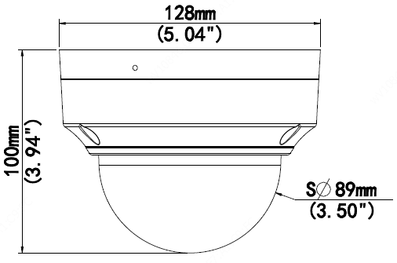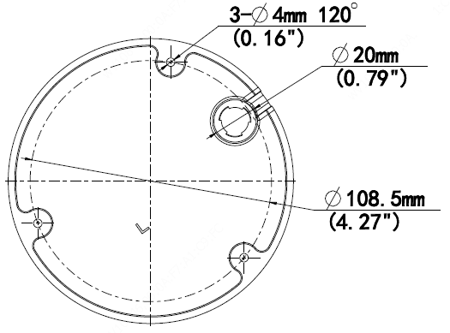

Accessories
TR-JB03-H-IN TR-JB07/WM03-F-IN TR-WM03-B-IN TR-UP06-IN TR-A01-IN
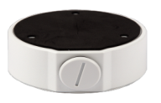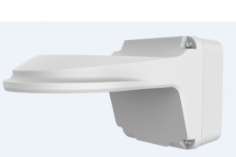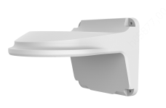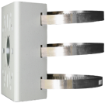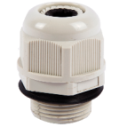

TR-SE24-IN TR-SE24-A-IN TR-CM24-IN
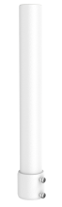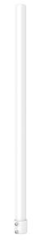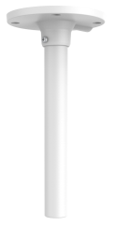

Junction Mount | Pole Mount
TR-JB03-H-IN | TR-JB07/WM03-F-IN(TR-WM03-B-IN)+TR-UP06-IN
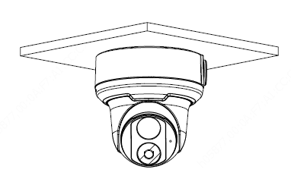 | 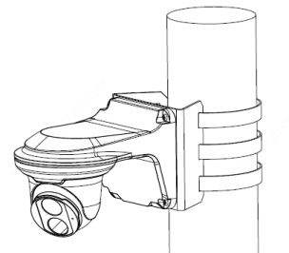
TR-CM24-IN+TR-JB03-H-IN
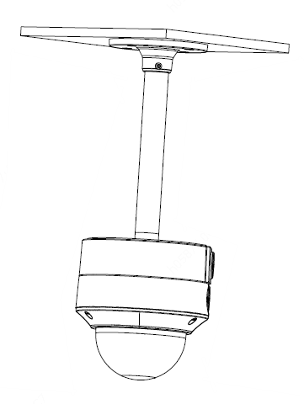

Zhejiang Uniview Technologies Co., Ltd.
Building No.10, Wanlun Science Park, Jiangling Road 88, Binjiang District, Hangzhou, Zhejiang, China (310051)
Email: overseasbusiness@uniview.com; globalsupport@uniview.com
http://www.uniview.com
©2021 Zhejiang Uniview Technologies Co., Ltd. All rights reserved.
*Product specifications and availability are subject to change without notice.

